USER MANUAL – REAL-TIME NETWORK MAP

TSG USER

User Configuration- > TSG User can add/remove CSD Users (Mobile Numbers)

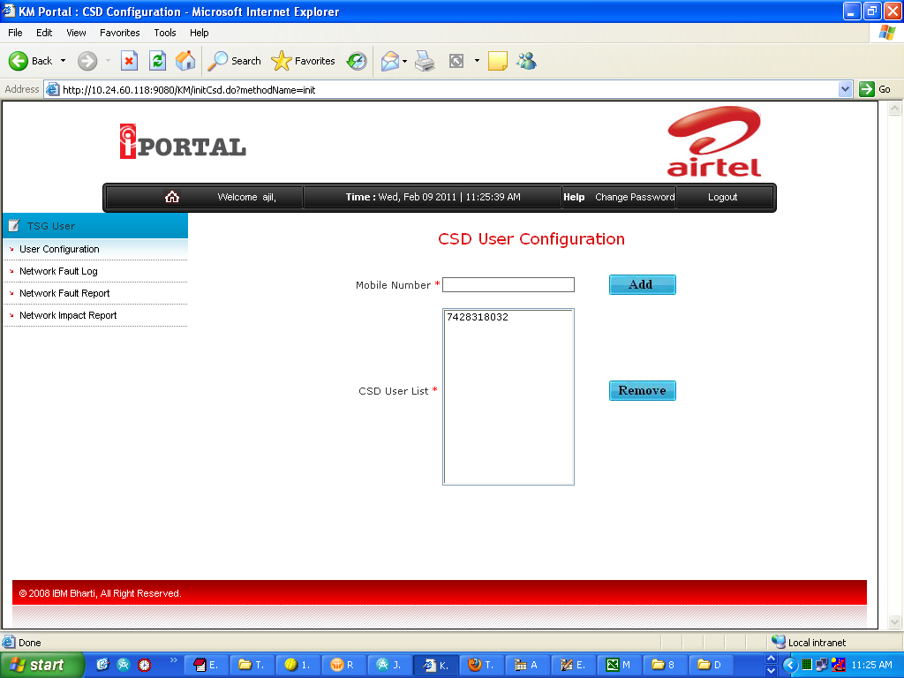
To Add User: - Enter Mobile Number of CSD user and click on Add, user is inserted into database and made visible into below list.
To Remove User: - Select Mobile Number(s) of CSD user from above list and click on Remove button, user is deleted from database.
Click on this link to add / remove CSD User (mobile number)

Network Fault Log- > TSG User inserts network fault related data such as problem description, affected areas, and total affected time (in HH:MM format). This data will be sent as SMS to all CSD Users (Mobile Numbers) registered for his/her country

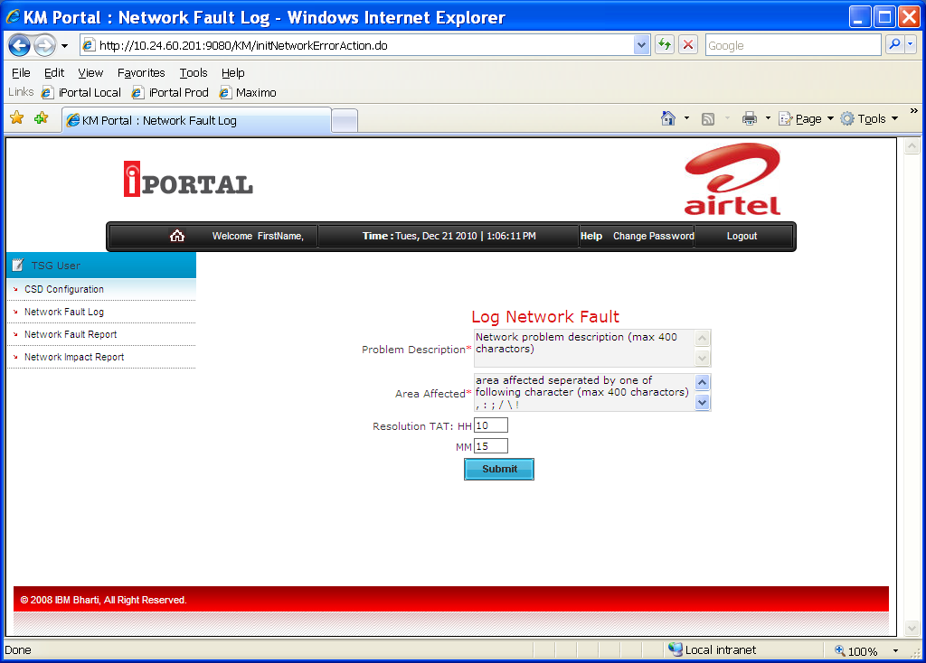
Enter Problem Description maximum up to 400 characters
Enter Area Affected maximum up to 400 characters
Enter Expected Hours of problem resolution in HH format & Minutes in MM format, Click on Submit.
Network Fault is inserted into System & SMSs are sent to registered CSD users.
Click on this link to Log Network Fault
Network Fault Report - > This shows MTD (month till date) or Daily Report of Network faults reported for his/her country

a. MTD (Month till Date) Report

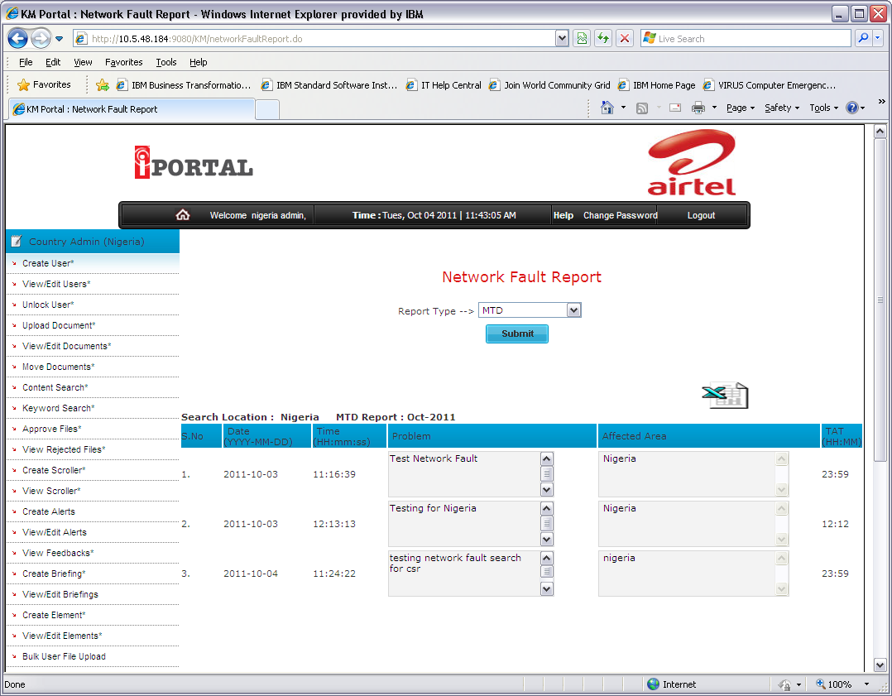
Select MTD and click on Submit button of Network Fault Report link
b. Daily Report

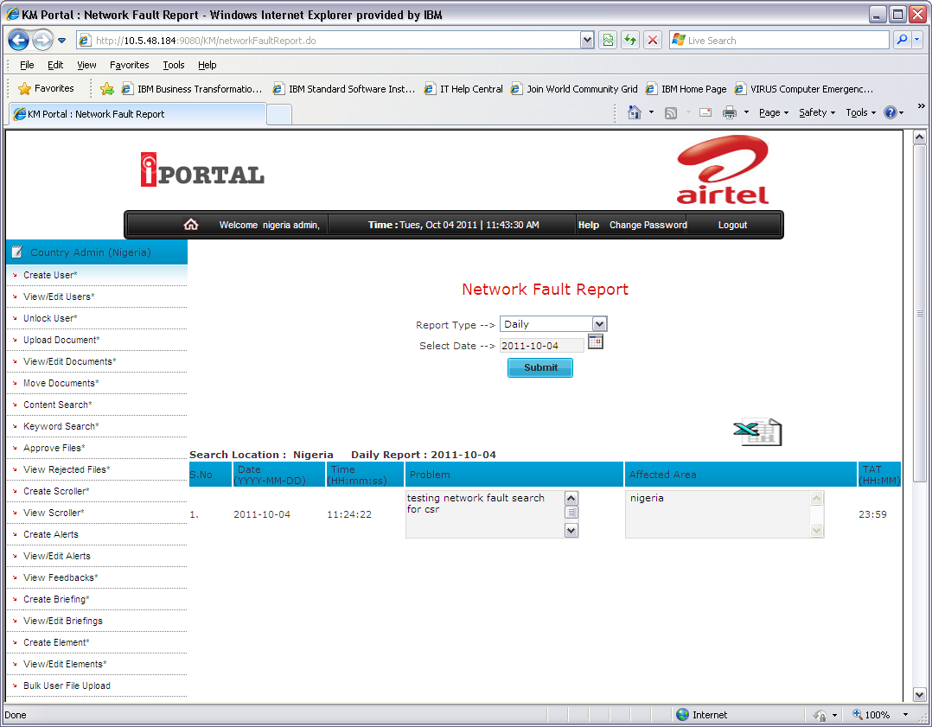
Select Daily from list
Select Date from calendar and click on Submit
Network Impact Report - > This shows MTD (month till date) or Daily Report of Total Affected Time (TAT) in HH:MM format for his/her country

a. MTD (Month till Date) Report

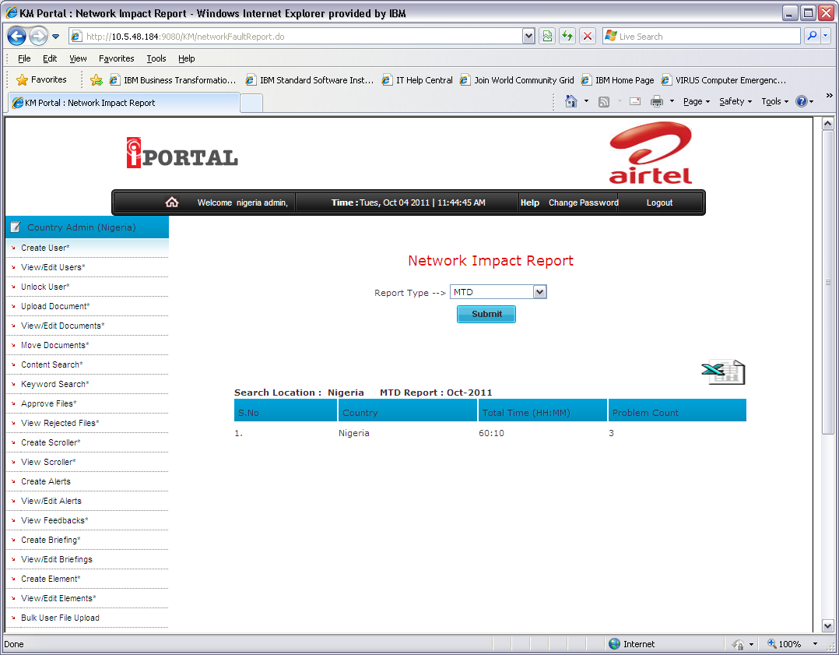
Select MTD and click on Submit button on Network Impact Report.

b. Daily Report

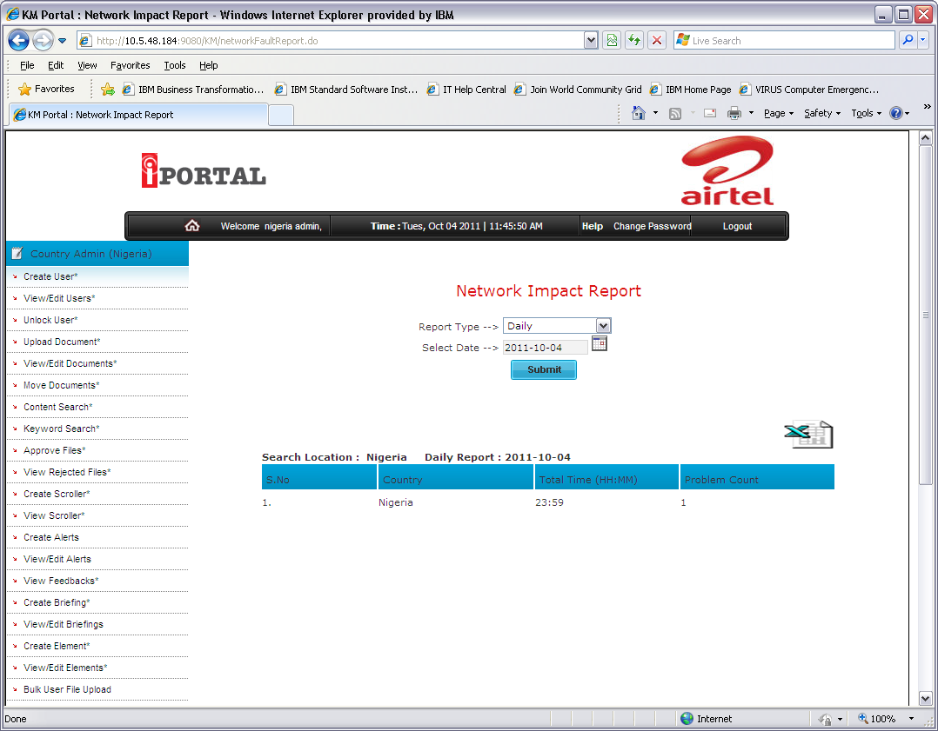
Select Daily from list
Select date from calendar, click on Submit button

